By the end of the SECOND LEARNING CYCLE
Chaparral Kindergarteners should be able to:
Reading and Writing
Recognize and name all capital and lower case letters in any order with automaticity. (At least 60 letters per minute)

Orally blend three and four letter sounds into given words.

/c/ /a/ /t/ = cat

/m/ /ee/ /t/ = meet

/b/ /a/ /ck/ = back

/s/ /k/ /i/ /p/ = skip
Name all of the 26 letter sounds with automaticity.

c . . . /c/

p . . . /p/

a . . . /a/

m . . . /m/

Read at least 30 of the kindergarten grade level sight words.

Write all alphabet letters, most letters formed correctly.

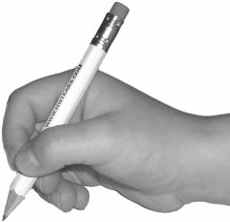
Independently writes information about a topic.

Cats are anumls. Tha hav shrp clos. Cats can run fast.

“Cats are animals. They have sharp claws. Cats can run fast.”

B c H I p D m x T V z A o U w Y e t a G q K E J t N M c P R
f T t d F H Z b j y K

Orally segment three and four phoneme words into their individual phonemes.

sat = /s/ /a/ /t/

pick = /p/ /i/ /k/

wild = /w/ /ie/ /l/ /d/

globe = /g/ /l/ /oa/ /b/
Blend letter sounds to read consonant, vowel, consonant (CVC) words.

map
ten
fib
dot
wet
rob

