By the end of this FIRST LEARNING CYCLE
Chaparral Kindergarteners should be able to:
Reading and Writing
Recognize and name most capital and lower case letters in any order with automaticity.

Orally blend three and four letter sounds into given words.

“/c/ /a/ /t/ “cat”

“/m/ /ee/ /t/” “meet”

“/b/ /a/ /ck/” “back”

“/s/ /k/ /i/ /p/” “skip”
Name many of the 26 letter sounds.

c . . . /c/

p . . . /p/

a . . . /a/

m . . . /m/

Recognize and reproduce rhyming words.

Do log and hog rhyme?

What rhymes with rose?
Use proper tripod pencil grip and write first name correctly.
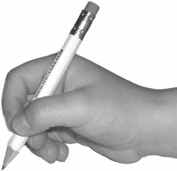
Write a brief sentence stating an opinion using alphabetic knowledge.

M b p wz f.

“My birthday party was fun.”

B c H I p D m x T V
z A o U w Y e t a G q K E r t N M c P R f T t d F H m

